CLASS X
PHYSICAL SCIENCE
Quick Learning Guide
Concepts • Activities • Formulae • Revision Points
How to use this guide: Read the key idea first, study the visual, remember the formula or rule, and then revise the activity steps and observation.

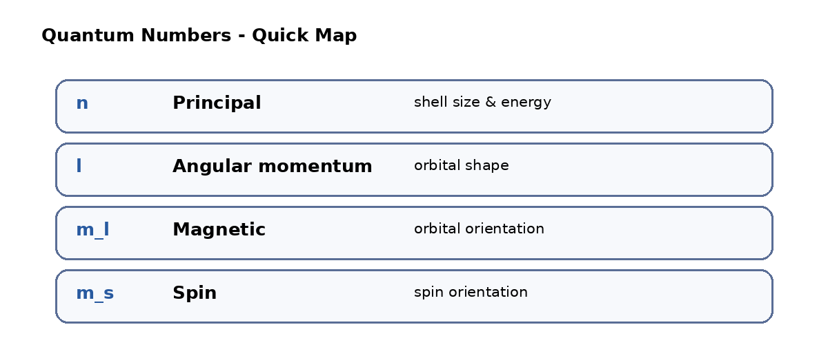

Contents
1. Reflection of Light at Curved Surfaces
2. Acids, Bases and Salts
3. Refraction of Light at Curved Surfaces
4. Human Eye and the Colourful World
5. Structure of Atom
6. Classification of Elements and Periodic Table
7. Chemical Bonding
8. Electric Current
9. Electromagnetism
10. Metallurgy
11. Carbon and Compounds
Revision tip Focus on definitions, formulae, comparison tables, activity observations and diagrams. These are presented in a short, exam-friendly format.

1. Reflection of Light at Curved Surfaces

Important terms
Term | Simple meaning / relation
Centre of curvature (C) | Centre of the spherical surface of which the mirror is a part.
Pole (P) | Midpoint of the spherical mirror.
Radius of curvature (R) | Distance between the pole and the centre of curvature.
Focal point (F) | Point where parallel reflected rays meet for a concave mirror.
Relation | R = 2f

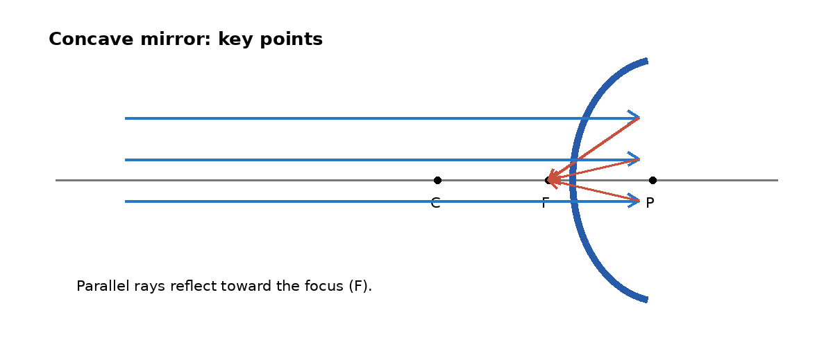
Schematic: principal axis, pole, focus and centre of curvature.

Concave mirror - image pattern
Object position | Image position | Size | Nature
At infinity | At F | Point-sized | Real
Beyond C | Between F and C | Small | Real and inverted
At C | At C | Same size | Real and inverted
Between C and F | Beyond C | Enlarged | Real and inverted
At F | At infinity | Highly enlarged | Real and inverted
Between F and P | Behind mirror | Enlarged | Virtual and erect

Mirror formula and magnification
Mirror formula 1/f = 1/v + 1/u

Magnification M = h_i / h_o = -v/u

- f = focal length
- v = image distance
- u = object distance
- h_i = height of image
- h_o = height of object

Sign conventions
- All distances are measured from the pole.
- Distance measured in the direction of incident light is taken as positive; the opposite direction is negative.
- Object/image above the principal axis is positive.
- Object/image below the principal axis is negative.

Activity
Aim: To find the focal length of a concave mirror.

Materials required: V-shaped stand, concave mirror, scale, candle, screen.
Procedure
1. Fix the concave mirror in the V-shaped stand.
2. Place a candle in front of the mirror.
3. Move the screen until a clear bright image is formed.
4. Measure the distance between the mirror and the screen.
Observation: The measured distance from the mirror to the sharp image on the screen is taken as the focal length.

Solar cooker / heater idea
- Use a parabolic wooden frame and plastic acrylic sheets.
- Face the arrangement toward sunlight.
- Adjust it so that reflected rays meet at one point.
- Place a container at the bright spot.
- The container becomes hot and the material inside cooks.

Concave mirror vs convex mirror
Convex mirror | Concave mirror
Reflecting surface is away from the centre of the sphere. | Reflecting surface is toward the centre of the sphere.
Focus lies behind the mirror. | Focus lies in front of the mirror.
Also called a diverging mirror. | Also called a converging mirror.
Forms virtual, erect and diminished images. | Image type depends on object position.

2. Acids, Bases and Salts

Basic ideas
- Acid: sour in taste, produces H+ ions, and changes blue litmus to red.
- Base: bitter in taste, produces OH- ions, and changes red litmus to blue.
- Olfactory indicators: substances whose smell changes in acidic or basic conditions; examples include onion, vanilla and clove oil.
- Neutralization: acid + base -> salt + water.
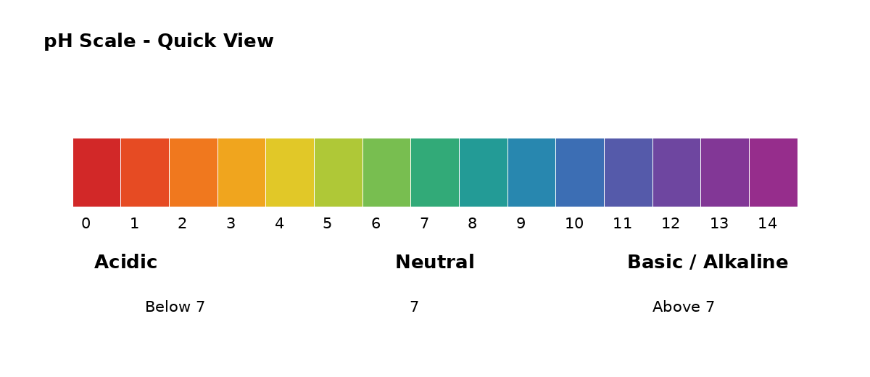

pH scale
- The pH scale has readings from 0 to 14.
- Below 7 is acidic.
- 7 is neutral.
- Above 7 is basic.

Importance of pH in everyday life
- Living organisms can survive only within a narrow pH range.
- If river-water pH becomes unsuitable, aquatic life becomes difficult.
- Tooth decay starts when pH falls below about 5.5.
- If stomach pH increases, food digestion may be affected.
- Plants require a suitable soil pH; the material notes 5.5 to 7.0 for growth.

Activity
Aim: To observe the reaction of an acid with a metal.

Materials required: Test tube, delivery tube, soap water, HCl, zinc.
Procedure
1. Put HCl in a test tube and add zinc granules.
2. Observe the gas released.
3. Bring a burning matchstick near the gas outlet.
Observation: A pop sound is observed, indicating hydrogen gas. Reactions shown: 2HCl + Zn -> ZnCl2 + H2; 2NaOH + Zn -> Na2ZnO2 + H2.

Activity
Aim: To observe the reaction of an acid with a metal carbonate.

Materials required: Test tube, delivery tube, lime water, HCl, Na2CO3.
Procedure
1. Put HCl in a test tube and add Na2CO3.
2. Pass the released gas through lime water.
Observation: Lime water turns milky due to CO2. Reactions shown: Na2CO3 + 2HCl -> 2NaCl + H2O + CO2; Ca(OH)2 + CO2 -> CaCO3 + H2O.

Dilution
Safe sequence Add acid or base to water. Do not add water directly to concentrated acid or base.

Common salts and uses
Substance | Uses
Bleaching powder (CaOCl2) | Cleaning drinking water; preparing chloroform; bleaching cotton.
Baking soda (NaHCO3) | Making cakes; fire extinguishers; mild antiseptic.
Washing soda (Na2CO3) | Soap and paper industry; cleaning agent; removing permanent hardness of water.
Plaster of Paris (CaSO4.2H2O) | Supporting fractured bones; making idols, toys and decorative materials.

Short answers
Which substance is present in an antacid tablet? Base.
What type of reaction takes place in the stomach? Neutralization reaction.
Why is Plaster of Paris packed in air-tight containers? Because it can react with air and form a hard substance.

Activity
Aim: To test soil pH.

Materials required: Test tube, water, fine soil, pH indicator.
Procedure
1. Add water to a test tube.
2. Add fine soil and mix.
3. Use pH indicator to check the soil.
Observation: A soil pH range of about 5.5 to 6 is given for this activity.

Water of crystallization
- Heat copper sulphate (CuSO4) in a test tube using a burner.
- Observe the colour change in the test tube.
- The observed colour change is from blue to white.

Water conducts electricity
- A simple circuit with a 6 V battery, bulb, switch and electrodes is used.
- The electrodes are dipped in dilute HCl solution to demonstrate conduction.

3. Refraction of Light at Curved Surfaces

Important terms
- Centre of curvature (C): centre of the spherical surface.
- Optic centre (O): midpoint of the lens.
- Radius of curvature (R): distance between optic centre and centre of curvature.
- Lens: transparent material bounded by two surfaces.
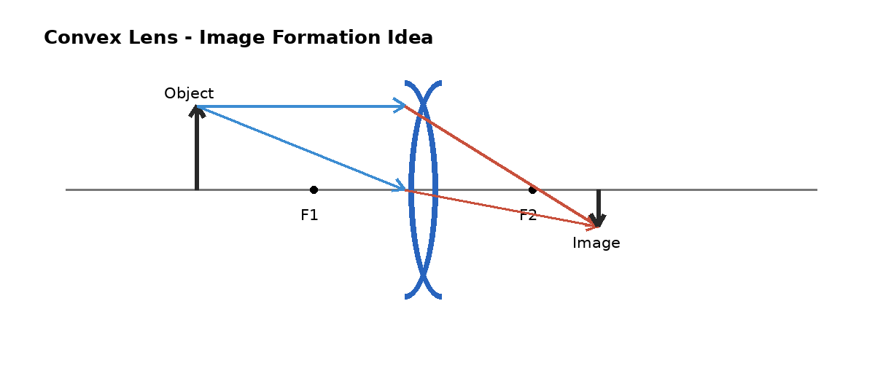

Convex lens image pattern
Object position | Image position | Relative size | Nature
At infinity | At focal point | Highly diminished | Real and inverted
Beyond 2F | Between F and 2F | Diminished | Real and inverted
At 2F | At 2F | Same size | Real and inverted
Between F and 2F | Beyond 2F | Magnified | Real and inverted
At F | At infinity | Highly magnified | Real and inverted
Between F and O | On same side as object | Magnified | Virtual and erect

Activity
Aim: To find the focal length of a convex lens.

Materials required: V-shaped stand, convex lens, scale, candle, screen.
Procedure
1. Fix the convex lens in the stand.
2. Place a candle in front of the lens.
3. Move the screen to obtain a clear image.
4. Measure the distance from lens to screen.
Observation: The measured distance for a sharp image is taken as the focal length in this activity.

Activity
Aim: To compare object distance and image distance for a lens.

Materials required: V-shaped stand, convex lens, scale, candle, screen.
Procedure
1. Place the lens in the stand and the candle in front.
2. Place the screen on the other side of the lens.
3. Adjust the screen to form a clear image.
4. Measure object and image distances for different object positions.
Observation: As object distance decreases, image distance is observed to increase in the stated activity.

Convex lens vs concave lens
Convex lens | Concave lens
Can form real and virtual images. | Always forms a virtual image.
Can form a magnified image. | Image is always diminished in size.

Lens formulae
Lens formula 1/f = 1/v - 1/u

Image formation relation n2/v - n1/u = (n2 - n1)/R

Lens maker formula 1/f = (n - 1)(1/R1 - 1/R2)

Real image vs virtual image
Real image | Virtual image
Light rays actually meet after reflection/refraction. | Light rays appear to meet.
Can be projected on a screen. | Cannot be projected on a screen.
Inverted with respect to the object. | Erect with respect to the object.

Activity
Aim: To show that focal length depends on the medium.

Materials required: Lens holder, convex lens, water, beaker, stone.
Procedure
1. Arrange the lens in the holder as shown in the activity.
2. Adjust to obtain a clear image of the stone.
3. Find the focal length with the lens in water.
Observation: The focal length of a lens is observed to depend on the medium.

4. Human Eye and the Colourful World

Vision basics
- Least distance of distinct vision: nearest distance at which a clear image can be seen. For a healthy person, about 25 cm.
- Values of about 1 to 2 m for aged people and 7 to 8 cm for children below 10 years are also given.
- Angle of vision: maximum angle at which the total image can be seen; about 60 degrees for a healthy person.
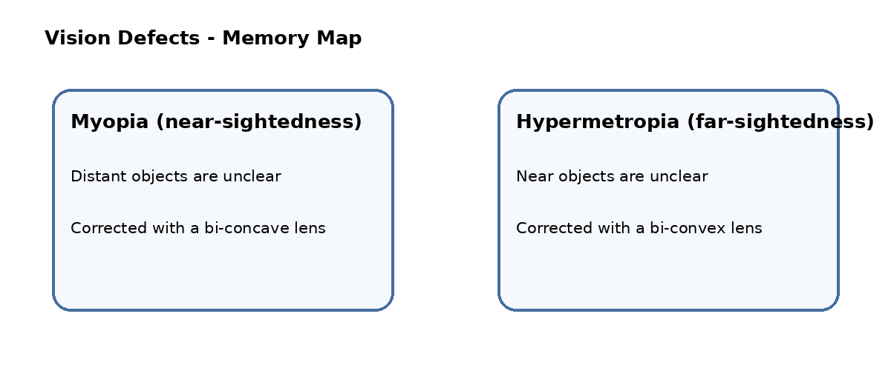

Myopia / short-sightedness / near-sightedness
- Near objects are seen clearly, while distant objects are unclear.
- Focal length is given as less than 2.5 cm.
- Rays converge before the retina.
- The maximum distance for a clear image is called the far point.
- Correction: bi-concave lens.

Hypermetropia / long-sightedness / far-sightedness
- Distant objects are seen clearly, while near objects are unclear.
- Focal length is given as greater than 2.27 cm.
- Rays converge after the retina.
- The minimum distance for clear image formation is called the near point.
- Correction: bi-convex lens.

Power of lens
Power (P) Reciprocal of focal length. SI unit: dioptre.

Refractive index of a prism - activity
- Place a prism on white chart and trace its outline P, Q and R.
- Take angle of prism A = 60 degrees.
- Draw a normal and incident ray, use pins, observe through the prism and mark emergent points.
- Extend rays and measure angles of incidence, emergence and deviation.
- The activity uses a graph of angle of deviation versus angle of incidence.
Refractive index relation n = sin((A + D)/2) / sin(A/2)

Dispersion of light
- Dispersion is the splitting of white light into seven colours (VIBGYOR).
- The activity uses water, a mirror, light and a screen to observe the separated colours.
- Rainbow formation is explained through refraction/dispersion in water drops.
- Violet is stated to deviate most and red least.
- The rainbow formation angle is given as about 40 degrees to 42 degrees.

Scattering of light
- Scattering is re-emission of light in different directions with different intensities.
- The activity uses hypo solution in a glass beaker and sulphuric acid.
- Blue appearance of the sky is linked to scattering of shorter wavelengths.
- Red appearance near sunrise and sunset is linked to the long path of sunlight through the atmosphere.
- On a hot day, water vapour/particles can scatter light and make the sky appear white.

5. Structure of Atom

Electromagnetic spectrum and Planck constant
- Electromagnetic spectrum: group of wavelengths of electromagnetic radiations.
- Planck constant: 6.626 x 10^-34 J s.

Bohr's model - main points
- Atom has a small positively charged nucleus.
- Electrons surround the nucleus.
- Energy of an electron in a permitted orbit does not change.
- Energy is emitted or absorbed when an electron jumps between energy levels.
- Energy change is expressed as E = E2 - E1.
- The model explains the spectrum of hydrogen.

Limitations stated
- Does not explain splitting of line spectra.
- Fails to explain the Zeeman and Stark effects.

Quantum numbers
Quantum number | Symbol | What it describes / values
Principal | n | Shell size and energy; K, L, M, N...; positive integers 1,2,3...
Angular momentum | l | Orbital shape; integer values 0 to n-1 (s, p, d, f correspond to 0,1,2,3).
Magnetic | m_l | Orientation of orbital; values from -l to +l including 0.
Spin | m_s | Spin orientation; +1/2 or -1/2.

Shell capacity
Shell | K | L | M | N
n | 1 | 2 | 3 | 4
No. of electrons | 2 | 8 | 18 | 32

Orbital capacities
Orbital | s | p | d | f
l | 0 | 1 | 2 | 3
Maximum electrons | 2 | 6 | 10 | 14

Electronic configuration rules
- Electronic configuration: distribution of electrons in shells and subshells.
- Pauli exclusion principle: no two electrons have the same four quantum numbers.
- Aufbau principle: ground-state configuration is built by filling lower-energy orbitals first.
- Hund rule: pairing starts only after available orbitals are singly filled.

Orbit vs orbital
Orbit | Orbital
Path around the nucleus in which electron revolves. | Region around the nucleus where probability of finding an electron is maximum.
Circular or elliptical path. | May be spherical, dumb-bell or double dumb-bell in shape.
Represents electron movement in one plane. | Represents electron movement in three-dimensional space.

6. Classification of Elements and the Periodic Table

Why classify elements?
- There are many elements.
- Studying their properties one by one is difficult.
- Classification helps us understand and compare their properties.

Early classification ideas
Idea | Main statement | Limitations mentioned
Dobereiner's triads | Elements arranged by atomic weight; middle atomic weight is the average of first and third. Examples: Li, Na, K; Ca, Sr, Ba. | Could not arrange all elements; failed for very low and very high masses.
Newlands' law of octaves | Elements arranged by increasing atomic weight; properties repeat at every eighth element. | Failed for elements heavier than Ca; no room for new elements; two elements could occupy the same slot.
Mendeleev's periodic law | Physical and chemical properties are periodic functions of atomic weight. | Anomalous pairs exist; dissimilar elements were placed together.

Mendeleev's contributions
- Divided elements into groups and periods.
- Predicted properties of missing elements.
- Corrected some atomic weights.
- Named upcoming elements such as eka-boron (scandium), eka-aluminium (gallium) and eka-silicon (germanium).

Modern periodic law
Modern periodic law Physical and chemical properties of elements are periodic functions of their atomic numbers or electronic configurations.

- Modern periodic table has 18 vertical columns called groups and 7 horizontal rows called periods.
- Elements are classified into s, p, d and f blocks according to the subshell receiving the last electron.

Periodic trends - quick table
Property | Down a group | Across a period (left to right)
Atomic radius | Increases | Decreases
Electropositive nature | Increases | Decreases
Metallic nature | Increases | Decreases
Ionization energy | Decreases | Increases
Electron affinity | Decreases | Increases
Electronegativity | Decreases | Increases
Non-metallic nature | Decreases | Increases
Valency | Same pattern within a group | Increases 1 to 4, then decreases to 0

7. Chemical Bonding

Need for chemical bonding
- Atoms form bonds to attain stability.
- Chemical bond: force of attraction between atoms in a molecule.
- Lewis dot structure represents valence electrons as dots around the element symbol.
- Octet rule: atoms tend to gain eight electrons in the valence shell to reach a stable configuration.

Ionic bond
- Ionic bond forms between oppositely charged ions.
- In NaCl formation, sodium loses an electron and chlorine gains it.
- MgCl2 formation is shown by loss of two electrons from Mg and gain by chlorine ions.

Factors affecting ionic bond
- Atomic size
- Ionization potential
- Electron affinity
- Electronegativity

Covalent bond
- Covalent bond is formed by mutual sharing of electrons between atoms.
- O2 is shown as an example of a double bond.
- N2 is shown as an example of a triple bond.

VSEPR idea and molecular shapes
Electron-pair arrangement | Example | Shape | Bond angle
2 bond pairs | BeCl2 | Linear | 180 degrees
3 bond pairs | BF3 | Trigonal planar | 120 degrees
4 bond pairs | CH4 | Tetrahedral | 109.28 degrees
3 bond pairs + 1 lone pair | NH3 | Trigonal pyramidal | 107.48 degrees
2 bond pairs + 2 lone pairs | H2O | V-shaped / bent | 104.31 degrees

Sigma bond vs pi bond
Sigma (sigma) bond | Pi (pi) bond
Formed by end-to-end overlap of orbitals. | Formed by lateral overlap of orbitals.
Overlap is along the internuclear axis. | Overlap occurs above and below the internuclear axis.
Stronger bond. | Weaker bond.
Electron cloud is symmetrical around the bond axis. | Electron cloud is not symmetrical around the bond axis.
Free rotation is possible. | Rotation is restricted.

O2 and N2 bonding
- O2: orbital overlap leads to one sigma bond and one pi bond, giving a double bond.
- N2: orbital overlap leads to one sigma bond and two pi bonds, giving a triple bond.
Covalence Number of covalent bonds present. Valence means the combining capacity of an atom.

8. Electric Current

Basic quantities
Quantity | Meaning / formula | SI unit
Current (I) | Charge flowing per unit time; I = Q/t | ampere (A)
Potential difference | Difference in electrical potential between two points | volt (V)
Resistance (R) | Opposition to current; in Ohm law V = IR | ohm
Power (P) | P = VI | watt (W)
Energy | Power x time | kWh; 1 kWh = 3.6 x 10^6 J

Charge fact 1 coulomb = 6.625 x 10^18 electrons.

Ohm's law
- At constant temperature, voltage is directly proportional to current.
- V proportional to I and V = IR.
- Ohmic materials follow a straight-line V-I graph.
- Non-ohmic materials show a curved V-I graph.
- Ohm law is noted as not applicable to semiconductors and gaseous conductors.

Activity
Aim: To show that voltage is directly proportional to current.

Materials required: 5 dry cells, wires, ammeter, voltmeter, iron/LED, key.
Procedure
1. Connect the circuit as shown in the experiment.
2. Close the key and note voltmeter and ammeter readings.
3. Repeat with 2 to 5 cells and record readings.
4. Calculate V/I and draw the graph.
Observation: For iron, voltage is proportional to current. The LED gives different readings/graph behavior.

Factors affecting resistance
- Temperature: resistance changes with temperature.
- Nature of material: different materials have different resistance.
- Length: R is directly proportional to length (R proportional to l).
- Cross-sectional area: R is inversely proportional to area (R proportional to 1/A).
Resistivity relation rho = RA/l; SI unit: ohm metre.

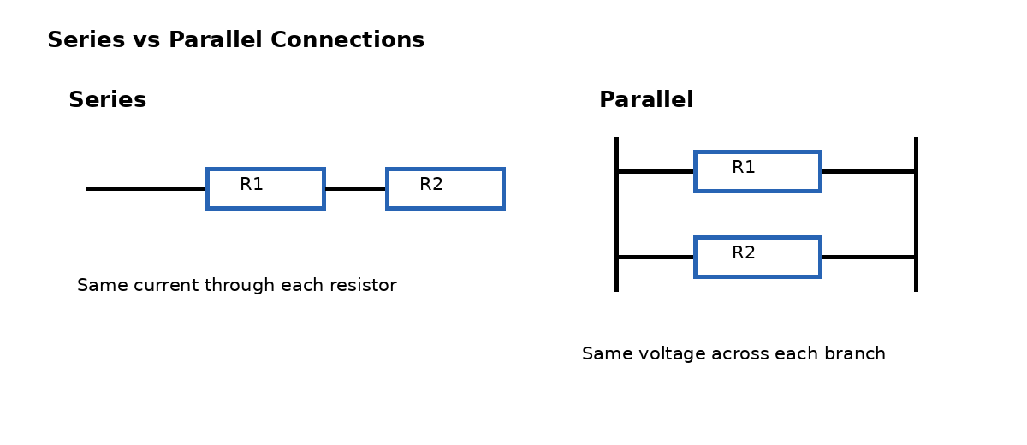

Series connection
- Current is the same through every part of the circuit.
- Total voltage = sum of individual voltages.
- Equivalent resistance: Req = R1 + R2 + R3 + ...

Parallel connection
- Voltage is the same across each branch.
- Total current = I1 + I2 + I3 + ...
- Equivalent resistance: 1/Req = 1/R1 + 1/R2 + 1/R3 + ...

Junction and loop laws
- Junction law: sum of currents entering a junction equals sum leaving it.
- Loop law: algebraic sum of all voltages in a closed loop is zero.

Safety terms
- Overloading: current drawn from the mains exceeds its limit.
- Short circuit: low-resistance connection between conductors supplying power.
- Fuse: safety device in an electric circuit.
- Electric shock: current passes through the body after contact with an electrical energy source.

Series vs parallel - advantages/disadvantages stated
Connection | Advantages | Disadvantages
Parallel | Each unit gets equal voltage; easy to connect/disconnect without affecting other elements; alternate paths may allow current to continue. | Requires more wire; voltage is not increased; not suitable when exactly the same current is required through units.
Series | Does not overheat easily; easy to learn/make; can add more power devices for higher voltage output. | If one point breaks, the circuit breaks; total resistance increases as components increase.

9. Electromagnetism

Magnetic field, flux and flux density
- Magnetic field: space around a magnet where magnetic effect is present.
- Magnetic flux (Phi): number of magnetic field lines passing through an area perpendicular to the field; Phi = BA cos theta; SI unit weber.
- Magnetic flux density (B): magnetic flux per unit area perpendicular to the field; SI unit tesla.
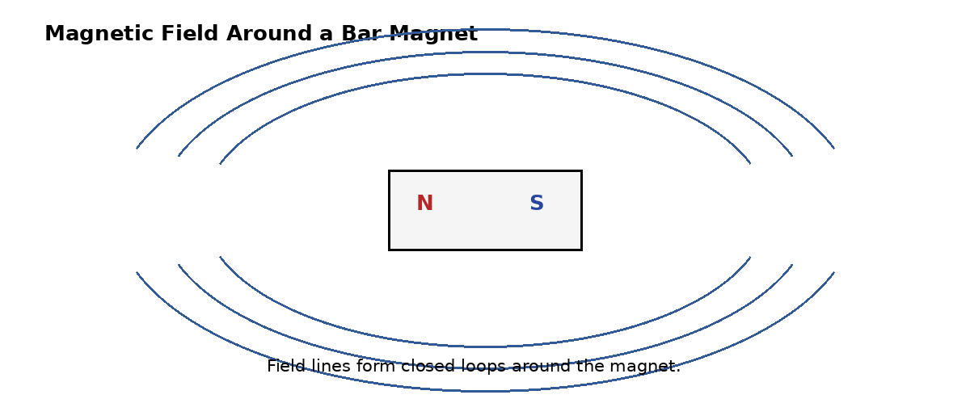

Activity
Aim: To show that a current-carrying conductor produces a magnetic field.

Materials required: Wooden board, copper wire, battery, magnetic compass, wooden sticks.
Procedure
1. Arrange the conductor and battery circuit.
2. Pass current through the copper wire.
3. Place a magnetic compass below/near the wire.
4. Observe the compass deflection.
Observation: The compass pointer deflects due to the magnetic field produced by the current-carrying wire.

Activity
Aim: To show that magnetic field lines are closed loops.

Materials required: Cardboard, bar magnet, iron dust, compass.
Procedure
1. Place a bar magnet on white cardboard.
2. Sprinkle iron dust around it.
3. Tap the board gently and observe the pattern.
Observation: Closed field-line patterns are observed around the bar magnet.

Straight wire, circular coil and solenoid
- A straight current-carrying wire produces circular magnetic field lines around it.
- A circular current-carrying coil produces a magnetic field.
- A current-carrying solenoid produces a magnetic field similar to a bar magnet.

Electric motor
- Principle: converts electrical energy into mechanical energy.
- Main parts listed: field magnet, armature, slip rings and brushes.
- A rectangular copper coil is placed between the poles of a horseshoe magnet.
- Current in the coil produces rotation.
- During rotation, contact with the split/slip-ring arrangement changes so that the coil continues rotating.

AC generator / dynamo
- Principle: converts mechanical energy into electrical energy.
- Main parts listed: field magnet, armature, slip rings and brushes.
- The rectangular coil rotates between magnetic poles.
- Current changes direction during rotation, producing alternating current (AC).

Faraday's law
Faraday's law The induced EMF generated in a coil is equal to the rate of change of magnetic flux.

Applications
- Security checking for detecting iron materials.
- Tape recorder operation.
- ATM card principle through electromagnetic induction.
- Induction stove.

10. Metallurgy

Definition and common ores
- Metallurgy: extraction of metals from their ores.
- Aluminium (Al) is identified as the most common metal in the earth.
Ore | Formula shown
Bauxite | Al2O3.2H2O
Epsom salt | MgSO4.7H2O
Hematite | Fe2O3
Cinnabar | HgS
Carnallite | KCl.MgCl2.6H2O

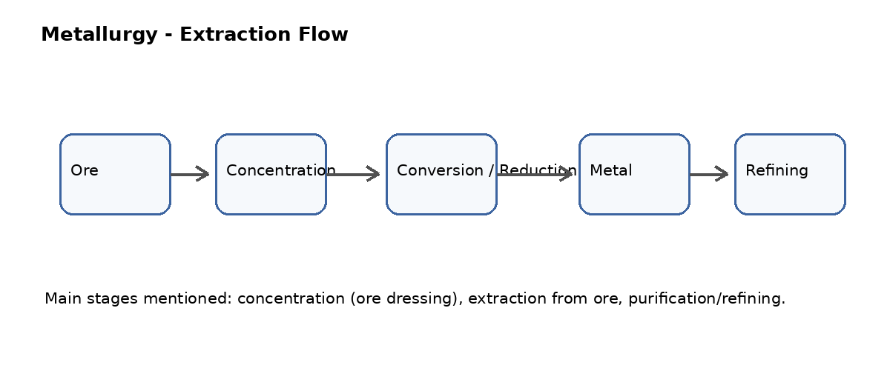

Main extraction stages
- Concentration or ore dressing.
- Extraction of metal from the ore.
- Purification / refining of metal.

Concentration methods
- Hand picking: impurities removed by colour and size.
- Washing: separates less-dense impurities from denser material.
- Froth flotation: used for sulphide ores; sulphide ore particles are separated using froth.
- Magnetic separation: removes magnetic impurities or separates magnetic material.

Extraction according to activity
- Highly active metals K, Na, Ca, Mg and Al: extraction by fused electrolysis.
- Moderately active metals Zn, Fe, Pb and Cu: sulphide/carbonate ores are converted to oxides and then reduced.
- Reduction with carbon: metal oxide reacts with carbon to form metal.
- Reduction with CO: metal oxide reacts with carbon monoxide to form metal.
- Self/auto reduction: partially roasted sulphide ore reacts further to form metal.
- Reduction with more reactive metals: a more active metal reduces the compound of a less active metal.

Thermit reaction
Reaction shown Fe2O3 + 2Al -> Al2O3 + 2Fe + heat

Refining methods
- Distillation: molten metal is distilled to obtain pure metal.
- Poling: molten metal is stirred with logs to produce slag.
- Liquation: low-melting metals are separated from high-melting materials.

Corrosion activity - rusting of iron nails
- Three test tubes are prepared using iron nails under different conditions.
- One has water and air; one uses boiled water with oil; one uses a drying chemical.
- The observation states that rusting occurs where both air and water are available.

Smelting, calcination and roasting
- Smelting: pyrometallurgical extraction using flux at high temperature.
- Flux: substance added to remove gangue from the ore.
Calcination | Roasting
Ore is heated in absence of air. | Ore is heated in presence of air.
Used for carbonate ores. | Used for sulphide ores.
Example: CaCO3 -> CaO + CO2 | Example: 2PbS + 3O2 -> 2PbO + 2SO2

Furnaces
- Furnace parts listed: hearth, fire box and chimney.
- Hearth: place where ore is kept.
- Fire box: place where fuel is kept.
- Chimney: outlet for waste gases.
- Reverberatory furnace: used for pyrometallurgical processes; fire box and hearth are separated.
- Blast furnace: used for pyrometallurgical processes; fire box and hearth are combined in a large chamber.

11. Carbon and Compounds

Carbon basics
- Carbon is a non-metal and belongs to group 14 (IVA).
- Carbon has 4 electrons in its valence shell.
- Carbon does not form C4- or a neon configuration because of its electronegativity, and does not form C4+ or a helium configuration because of very high energy requirement.
- Carbon can form four covalent bonds.
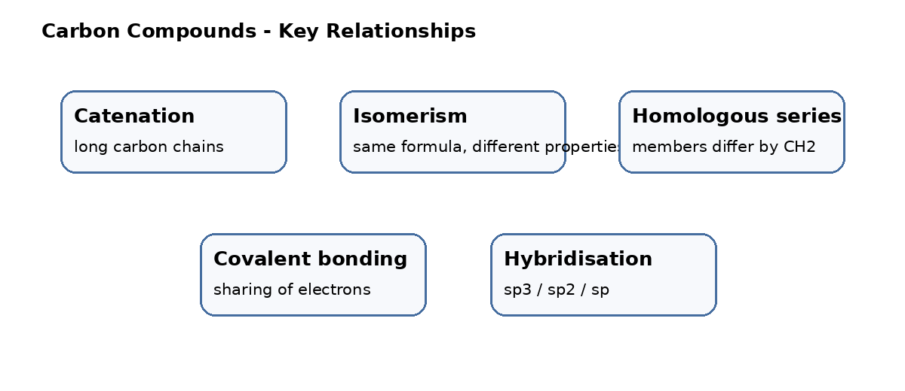

Allotropes of carbon
- Allotropy: property of an element to exist in two or more physical forms.
- Amorphous forms listed: coal, coke and charcoal.
- Crystalline forms listed: diamond and graphite.

Crystalline forms
Form | Key points
Diamond | Each carbon is attached to four carbons; 3-D structure; strong C-C bonds; poor conductor; hard material; sp3 hybridisation.
Graphite | Each carbon is attached to three carbons; 2-D structure; weaker C-C bonding; good conductor; soft material; sp2 hybridisation.
Buckminsterfullerene C60 | 12 pentagons and 20 hexagons; football/soccer-ball shape; sp2 hybridisation; uses mentioned in antibiotics and treatment of cancer.
Nanotubes | Allotropic form of carbon; uses mentioned in molecular wires and ICs.

Special properties
- Catenation: ability to form long chains.
- Isomerism: ability to form compounds with the same molecular formula but different properties.
- Homologous series: series of carbon compounds differing by CH2.

Chemical properties
- Combustion: carbon burns in excess oxygen to produce heat and light. C + O2 -> CO2.
- Oxidation: oxidising agents oxidise another substance. Example shown: C2H5OH -> CH3CHO -> CH3COOH.
- Addition reaction: unsaturated compounds become saturated; example sequence shown from C4H6 to C4H8 to C4H10.
- Substitution reaction: one atom is replaced by another; chlorination of methane is shown stepwise from CH4 to CCl4.

Catalyst
Catalyst A substance that regulates the rate of a reaction. Example mentioned: Ni.

Ethanol / ethyl alcohol
- Prepared from ethene by addition of water: C2H4 + H2O -> C2H5OH.
- Uses mentioned: medicines and cough syrups.

Activity
Aim: To demonstrate esterification.

Materials required: Test tube, beaker, glass rod, stand, burner, dropper.
Procedure
1. Add alcohol and acetic acid to a test tube in the presence of sulphuric acid.
2. Warm water in a beaker on a stand.
3. Place the test tube in the warm-water bath and observe the reaction.
Observation: A sweet-smelling substance called an ester is formed. Reaction shown: CH3COOH + C2H5OH -> CH3COOC2H5 + H2O.

Uses of esters
- Soaps and detergents.
- Plastics and clothes.
- Perfumes.
- Organic solvents.

True solution vs colloid
True solution | Colloid
Particle size is less than 1 nm. | Particle size ranges from 1 to 100 nm.
Homogeneous. | May appear homogeneous but is heterogeneous.

Micelle formation and cleaning action of soap
- Take two test tubes A and B. Add water and oil to both; add soap to B and shake.
- Micelle formation is observed in the soap-containing tube.
- Soap molecule has a hydrophilic end and a hydrophobic end.
- Hydrophilic end is directed toward water; hydrophobic end toward oily dirt.
- Soap molecules arrange around dirt, helping remove it from cloth.

Hybridisation
Type | Example | Shape / angle | Bonds stated
sp3 | CH4 | Tetrahedral; 109.5 degrees | 4 sigma bonds
sp2 | C2H4 (ethene) | Trigonal planar; 120 degrees | 1 pi bond and 5 sigma bonds
sp | C2H2 (ethyne/acetylene) | Linear; 180 degrees | 2 pi bonds and 3 sigma bonds

Quick Revision Formula Sheet
Topic | Formula / key relation
Curved mirror | R = 2f
Mirror formula | 1/f = 1/v + 1/u
Mirror magnification | M = h_i/h_o = -v/u
Lens formula | 1/f = 1/v - 1/u
Lens maker formula | 1/f = (n - 1)(1/R1 - 1/R2)
Prism refractive index | n = sin((A + D)/2) / sin(A/2)
Ohm law | V = IR
Resistance relation | R proportional to l/A
Resistivity | rho = RA/l
Series resistance | Req = R1 + R2 + ...
Parallel resistance | 1/Req = 1/R1 + 1/R2 + ...
Electric power | P = VI
Magnetic flux | Phi = BA cos theta
Energy conversion | 1 kWh = 3.6 x 10^6 J

Last-minute revision Revise definitions, formulae, comparison tables, activity observations, image positions, pH rules, periodic trends, bonding shapes and circuit relations.

